Project Title: Signs with Smart Connectivity for Better Road Safety Problem Solution Fit Team ID: PNT2022TMID37463

There was a network effect on the testing. a significant and unexpected component Because of this IoT-based system was successful in simulating a large-scale smart sign board.

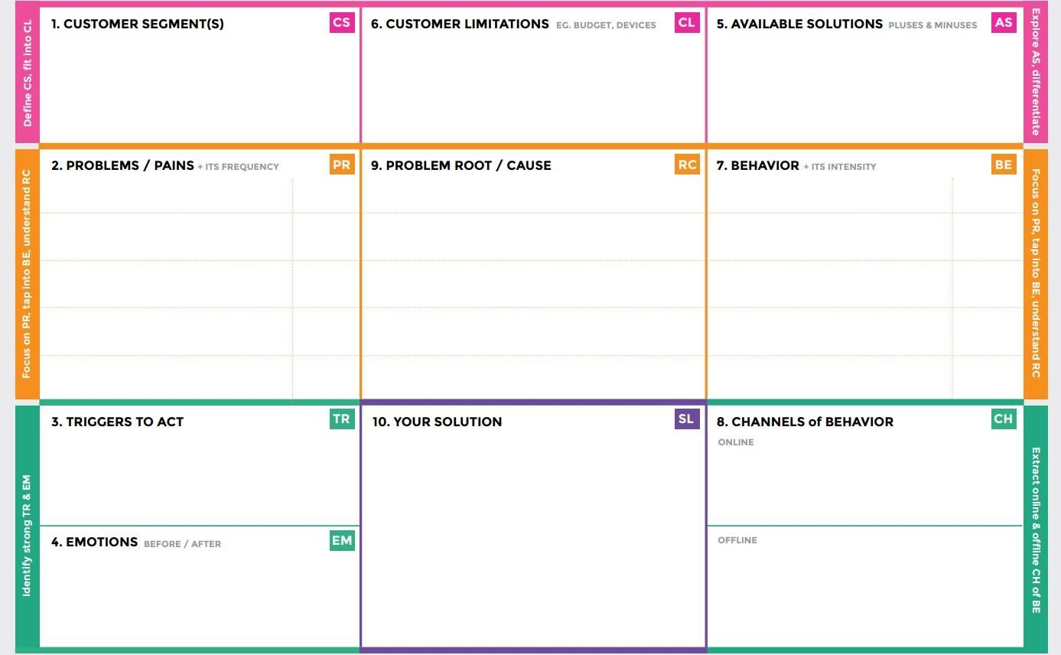

**mperature sensor readings and telling the board o**

**variety of tasks, including maintaining accurate te**

Along roadways, inactive signs with clear directions are put as potential fixes.

The Smartboard Connectivity is responsible for a

f the speed of the customer's vehicle.

If there was no internet connection, no sensor data from the weather would cause the speed limit to change. Some persons may cause issues by hitting the accident indicator button unnecessarily.

**As a teacher, the IOT cloud upgrades the smartboard on the condition of the roads on a regular basis.**

**Poor climate conditions win. The vehicle should be moving at edge speed. The sensor value should be appeared on the smart board of alarm the client.**

Clients will feel better after selecting an operation mode with the use of smartboard connectivity, and they will then follow the instructions on the smartboard.

We utilize smart connected sign boards as an alternative to inactive signboards. With the help of a web app

and climate API, these intelligent connected sign boards automatically.

**The divisions can get coordinate emails or messages from customers.**

**This are the following directions this is the one of the main tasks for the travelers. but they can use the smartboard signs to check the state of the road from wherever they are.**